Answer the following questions:

1. The Wikipedia article on refactoring talks about code smell and one motivation for engaging in refactoring. What is code smell? Describe briefly two examples of "code smell" and how refactoring would eliminate them.

**Answer**

|  |
| --- |
| **Code smell is a small part of a program that is wrong and could cause deeper problems later on. Refactoring would stop this because you would have the perfected code in a procedure so you wouldn't be able to mess up the same thing over and over again.** |

2. Insert a screenshot of the procedure from your app below.

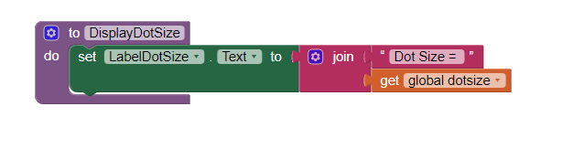

3. What are the advantages of using procedural abstraction? Try to name at least 2 advantages.

**Answer**

|  |
| --- |
| **Procedural Abstraction makes code smaller and more easy to understand. You also don't have to remember exactly how to do every small function or process. It also makes your code more compact.** |